

A Project Report on
The Haunted House
submitted to EXTENDED REALITY (ADS351)
by

Name | Sreerag P, Thanya Suresh, Koushikee Chakrabartty
Register No | 2562559, 2562562, 2562531
Class/Section | 3BTCS DS

FACULTY IN-CHARGE: Chaitra P C

DEPARTMENT OF AI AND DATA SCIENCE ENGINEERING SCHOOL OF ENGINEERING AND TECHNOLOGY
CHRIST (DEEMED TO BE UNIVERSITY)
Academic Year: 2026-27



DEPARTMENT OF AI AND DATA SCIENCE ENGINEERING SCHOOL OF ENGINEERING AND TECHNOLOGY

CERTIFICATE

This is to certify that Mr./Ms. Sreerag P, Thanya Suresh, Koushikee Chakrabartty, bearing Register No. 2562559, 2562562, 2562531 has satisfactorily completed the project work titled The Haunted House in the laboratory course, ADS351- Extended Reality prescribed by the Department of AI and Data Science Engineering, CHRIST (Deemed to be University) for the III semester B.Tech. program during the academic year 2026-27.

Prof. Chaitra P C Dr Michael Moses T
Faculty In-charge Head of the Department

Date: 18-09-2026
Place: Bangalore

Vision
“Excellence and Service”

Mission
“CHRIST (Deemed to be University) is a nurturing ground for an individual’s holistic development to make effective contribution to the society in a dynamic environment.”

Core Values
Faith in God Moral Uprightness
Love of Fellow Beings Social Responsibility Pursuit of Excellence

Department Vision
“To excel in human-centred AI and data-driven innovation through ethical research, societal well-being, and transformative collaborations”

Department Mission
M1: Empowering individuals to ethically harness data and AI through accessible and value-driven curriculum.
M2: Foster a dynamic research environment that advances innovative and impactful solutions for the betterment of global well-being.
M3: Innovate scientific knowledge and Entrepreneurship through academia and Industry collaborations.

Data Science Program Educational Objectives (PEOs)
PEO1: Understand, analyze and design solutions with professional competency for the real-world problems.
PEO2: Develop software / embedded solutions for the requirements, based on critical analysis and research.
PEO3: Function effectively in a team and as an individual in a multidisciplinary/multicultural environment.
PEO4: Accomplish holistic development comprehending professional responsibilities.

Program Outcomes (POs)
PO1: Engineering Knowledge: Apply knowledge of mathematics, natural science, computing, engineering fundamentals and an engineering specialization to develop the solution of complex engineering problems.
PO2: Problem Analysis: Identify, formulate, review research literature and analyze complex
engineering problems reaching substantiated conclusions with consideration for sustainable development.
PO3: Design/Development of Solutions: Design creative solutions for complex engineering
problems and design/develop systems/components/processes to meet identified needs with consideration for the public health and safety, whole-life cost, net zero carbon, culture, society and environment as required.
PO4: Conduct Investigations of Complex Problems: Conduct investigations of complex
engineering problems using research-based knowledge including design of experiments, modelling, analysis & interpretation of data to provide valid conclusions.
PO5: Engineering Tool Usage: Create, select and apply appropriate techniques, resources
and modern engineering & IT tools, including prediction and modelling recognizing their limita-tions to solve complex engineering problems.
PO6: The Engineer and The World: Analyze and evaluate societal and environmental
aspects while solving complex engineering problems for its impact on sustainability with reference to economy, health, safety, legal framework, culture and environment.
PO7: Ethics: Apply ethical principles and commit to professional ethics, human values,
diversity and inclusion; adhere to national & international laws.
PO8: Individual and Collaborative Team work: Function effectively as an individual, and as a member or leader in diverse/multi-disciplinary teams.
PO9: Communication: Communicate effectively and inclusively within the engineering com-
munity and society at large, such as being able to comprehend and write effective reports and design documentation, make effective presentations considering cultural, language, and learning differences.
PO10: Project Management and Finance: Apply knowledge and understanding of engi-
neering management principles and economic decision-making and apply these to one’s own work, as a member and leader in a team, and to manage projects and in multidisciplinary environments.
PO11: Life-Long Learning: Recognize the need for, and have the preparation and ability for
i) independent and life-long learning ii) adaptability to new and emerging technologies and iii) critical thinking in the broadest context of technological change.

Program Specific Outcomes (PSOs)
Data Science :To utilize Data Science principles to formulate the appropriate solutions for the real-world problems
Data Analytics :To assess the models of data analysis, quality of inputs and investigate the issues.
Service Learning: : Analyze Social Relevant Problems and design solutions through Service Learning
.
Evaluation Rubrics
- The following evaluation rubrics followed for assessment:
  - Project Design, Technical Skills Tools Usage: 10 marks
  - Implementation: 10 marks
  - Innovation / Creativity: 10 marks
  - Documentation / Report Quality: 100 marks
  - Individual Contribution, Presentation: 10 marks

No. | Component | Date | Marks | Signature
1 | Project Design, Technical Skill and and Tools Usage (10)
2 | Implementation (10)
3 | Innovation / Creativity(10)
4 | Documentation / Report and quality (10)
5 | Individual Contribution, Presentation(10)
Total (50)

Contents
- Introduction 9
  - Context and Background Study . . . . . . . . . . . . . . . . . . . . . . . . . . . . . . . . 9
  - Need Analysis . . . . . . . . . . . . . . . . . . . . . . . . . . . . . . . . . . . . . . . . . 9
  - Overview of the project . . . . . . . . . . . . . . . . . . . . . . . . . . . . . . . . . . . . 9
  - Steps . . . . . . . . . . . . . . . . . . . . . . . . . . . . . . . . . . . . . . . . . . . . . . 9
  - Home Page 10
- Project Setup and Environment 11
  - Overview 11
  - Steps 11
  - Collectible Configuration 12
- Gameplay and Ritual Interaction 14
  - Overview 14
  - Steps 14
  - Ritual Interaction 15
- Output Testing and conclusion 16
  - Overview 16
  - Output- Successful Completion 17
  - Output 17
  - Conclusions 18
  - Scope for Future Work 18
5 References 19

CHAPTER 1
Introduction
CONTEXT AND BACKGROUND STUDY
Extended Reality (XR) combines interactive digital environments with computer-generated visual and audio elements. This project applies XR-related interaction concepts through a first-person haunted-house game developed in Unity. The environment is designed as an exploratory experience in which the player searches for objects, responds to clues, manages limited time, and reaches a final ritual sequence.
NEED ANALYSIS
A conventional walkthrough can become repetitive when the player has no clear objective or consequence for delay. The proposed game introduces exploration, interaction and time pressure to make the experience more engaging. A simple object-collection system, hint mechanism, audio feedback and alternate success/failure endings provide clear gameplay progression while remaining manageable for a student-level Unity project.
OVERVIEW OF THE PROJECT
The project is a first-person haunted-house escape game. The player starts from a title screen and receives two minutes to locate five required objects: an Old Key, Single Flame Candle, Mysterious Note, Doll and Mysterious Amulet. The player receives an on-screen objective, object status list and timer while exploring the house.
STEPS
• Create a Universal Render Pipeline Unity project and import the haunted-house environment assets.
• Set up a first-person player with collision, gravity and movement.
• Place the five collectible objects and configure their interaction distances.
• Create the gameplay UI for objectives, object status and remaining time.
• Add footsteps and environmental audio to improve immersion.
• Implement the ritual interaction and separate success and timeout endings.

CHAPTER 1
Home Page
OVERVIEW
The home page introduces the game title and the main objective before gameplay begins. The Start Game button activates the player, displays the gameplay interface and starts the two-minute timer.
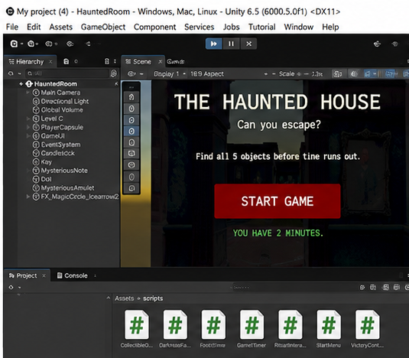
Figure 1.1: Unity Editor view showing the Haunted House project and Start Game interface.
STEPS
• Design the Start Panel inside the main GameUI canvas.
• Add the game title, short objective message and Start Game button.
• Keep the player controller disabled while the start screen is active.
• Enable the player and start the timer when Start Game is pressed.
OUTPUT
The result is a clear entry screen that communicates the time limit and objective before the player enters the haunted environment.

CHAPTER 2
Project Setup and Environment
OVERVIEW
The haunted-house environment provides the main exploration space. The project uses a prebuilt multi-room environment and adds the player, lighting, collectible objects and interaction scripts around it.
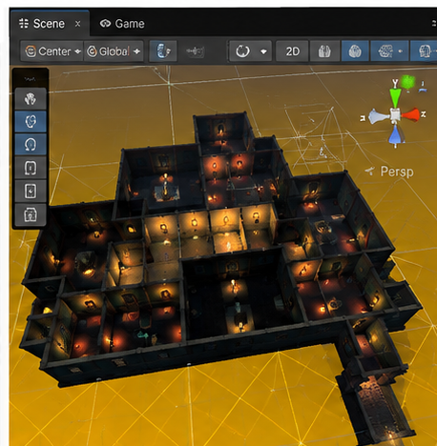
Figure 2.1: Scene view showing the multi-room haunted-house environment.
STEPS
• Import and place the Level_C haunted-house environment in the Unity scene.
• Use the existing environmental lighting and flickering light effects from the asset.
• Add the PlayerCapsule and configure its Character Controller for the environment.
• Create the GameUI hierarchy containing gameplay, ending and interaction panels.
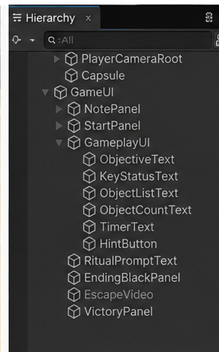
Figure 2.2: Unity Hierarchy showing the player, gameplay UI, ending panels and interaction elements.
COLLECTIBLE CONFIGURATION
Each collectible uses a collider and the CollectibleObject script. The script stores the object's index and name, detects the player's interaction ray and updates the object counter and objective.
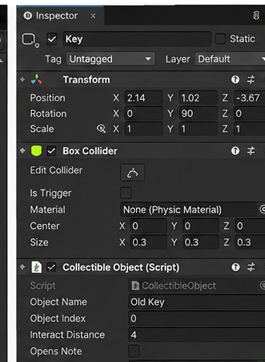
Figure 2.3: Inspector view showing the CollectibleObject configuration for the Old Key.

CHAPTER 3
Gameplay and Ritual Interaction
OVERVIEW
During gameplay, the player explores the house while the timer counts down. The interface keeps the current objective, object list and remaining time visible. Interaction is performed by looking at a required object and pressing E.
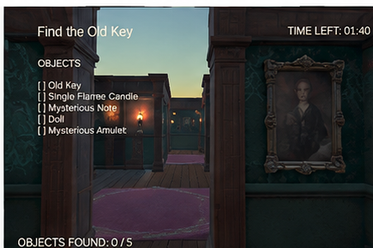
Figure 3.1: In-game interface showing the current objective, object list and countdown timer.
STEPS
• Start the timer when the player selects Start Game.
• Display the current object objective at the top-left of the screen.
• Update the object list and count whenever a collectible is obtained.
• Show the note panel when the Mysterious Note is collected.
• After all five objects are collected, direct the player toward the ritual room.
• Display a ritual prompt when the player looks at the ritual interaction area.
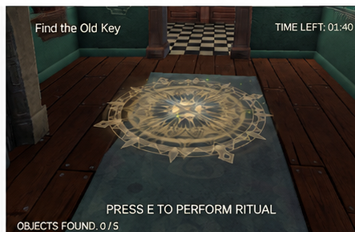
Figure 3.2: In-game ritual circle with the prompt to perform the final ritual.
RITUAL INTERACTION
The ritual interaction acts as the final gameplay trigger. When the player looks at the ritual circle within the interaction distance and presses E, movement is disabled and the ending sequence begins. The lighting fades to darkness before the escape video is played.

CHAPTER 4
Output, Testing and Conclusion
OVERVIEW
The game contains two distinct end conditions. Completing the required collection and ritual leads to the escape sequence, while allowing the timer to reach zero triggers the ghost sequence and Game Over screen.
OUTPUT — SUCCESSFUL COMPLETION
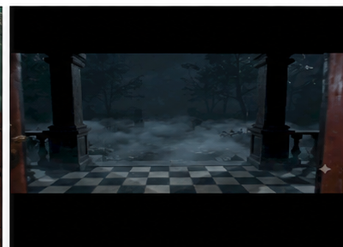
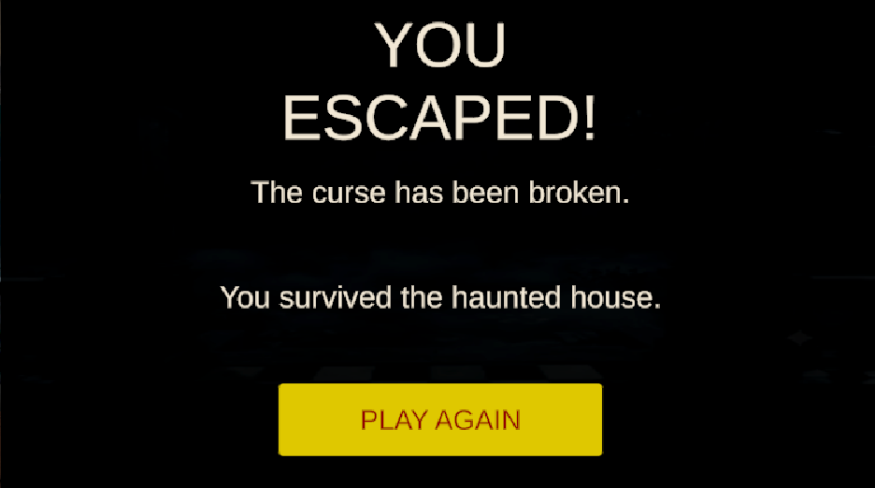

Figure 4.1: Escape sequence video displayed after successful completion of the ritual.
After the ritual is completed, the gameplay interface is hidden, the scene fades to darkness and the escape sequence is played. This provides a visual transition from the haunted house to the successful ending.

OUTPUT — TIMEOUT
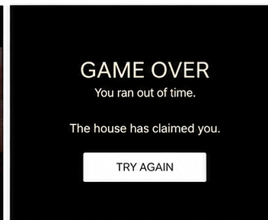
Figure 4.2: Game Over screen displayed after the countdown reaches zero.
If the timer expires before the required objectives are completed, the player is stopped and the ghost jumpscare sequence is displayed. After the video ends, the Game Over panel provides a Try Again option that reloads the scene.
CONCLUSIONS
The project successfully combines a first-person environment, object-based interaction, UI feedback, time-limited exploration, audio effects, a ritual trigger and separate success and failure sequences. The implementation demonstrates how Unity components and C# scripts can be combined to create an interactive XR-oriented experience.
SCOPE FOR FUTURE WORK
• Add VR controller support and headset-based interaction.
• Introduce more adaptive hints and additional environmental events.
• Add more rooms, puzzles and collectible objectives.
• Improve audio variation and spatial audio for greater immersion.
• Add save/progress handling and multiple difficulty levels.

References

[1] Unity Technologies, Unity User Manual and scripting documentation, Unity 6 documentation.
[2] Unity Technologies, Universal Render Pipeline documentation and project setup guidance.
[3] Unity Asset Store, 3D Stealth Game: Haunted House asset package used as the base environment.
[4] Project implementation files and C# scripts developed for the Haunted House Extended Reality project.

